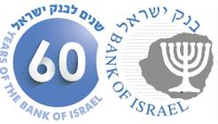

BANK OF ISRAEL

Office of the Spokesperson and Economic Information

November 23, 2015

**Press Release**

**Completion of automated-machine operators’ preparations ahead of the**

**NIS 200 banknote of the new series (Series C of the New Shekel) entering circulation**

The Bank of Israel reports that during December 2015 the new NIS 200 banknote—the second denomination issued in the new series—is expected to enter circulation. The precise date will be announced in the next few days.

Within the framework of the preparations for issuing the new banknote, automated-machine operators are required to complete the calibration of vending machines and banknote counting machines, through software which identifies the NIS 200 banknote of the new series (Series C of the New Shekel).

The Bank of Israel Currency Department calls on operators of automated machines and of banknote counting machines, that have not finished calibrating the machines they operate, to contact the suppliers of the machines shortly in order to calibrate the ones in their possession, so that the automated machines will be ready to accept the new banknote as soon as it is distributed.

The Bank of Israel Currency Department will publish additional information regarding the new NIS 200 banknote, and the security features it incorporates, shortly. Further information is available by email at [contact_currency@boi.org.il](mailto:contact_currency@boi.org.il), or by telephone at 1-800-300-018 and noting name and telephone number.

**Pictures of the banknote:**

**Front**

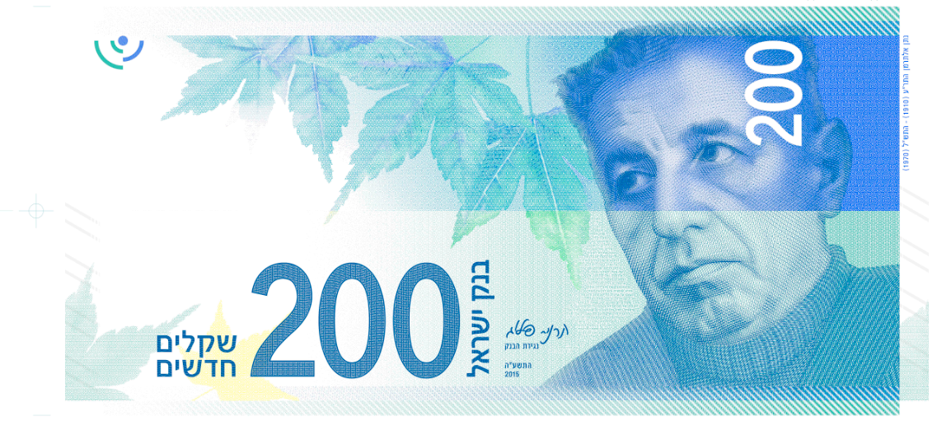

**Back**

